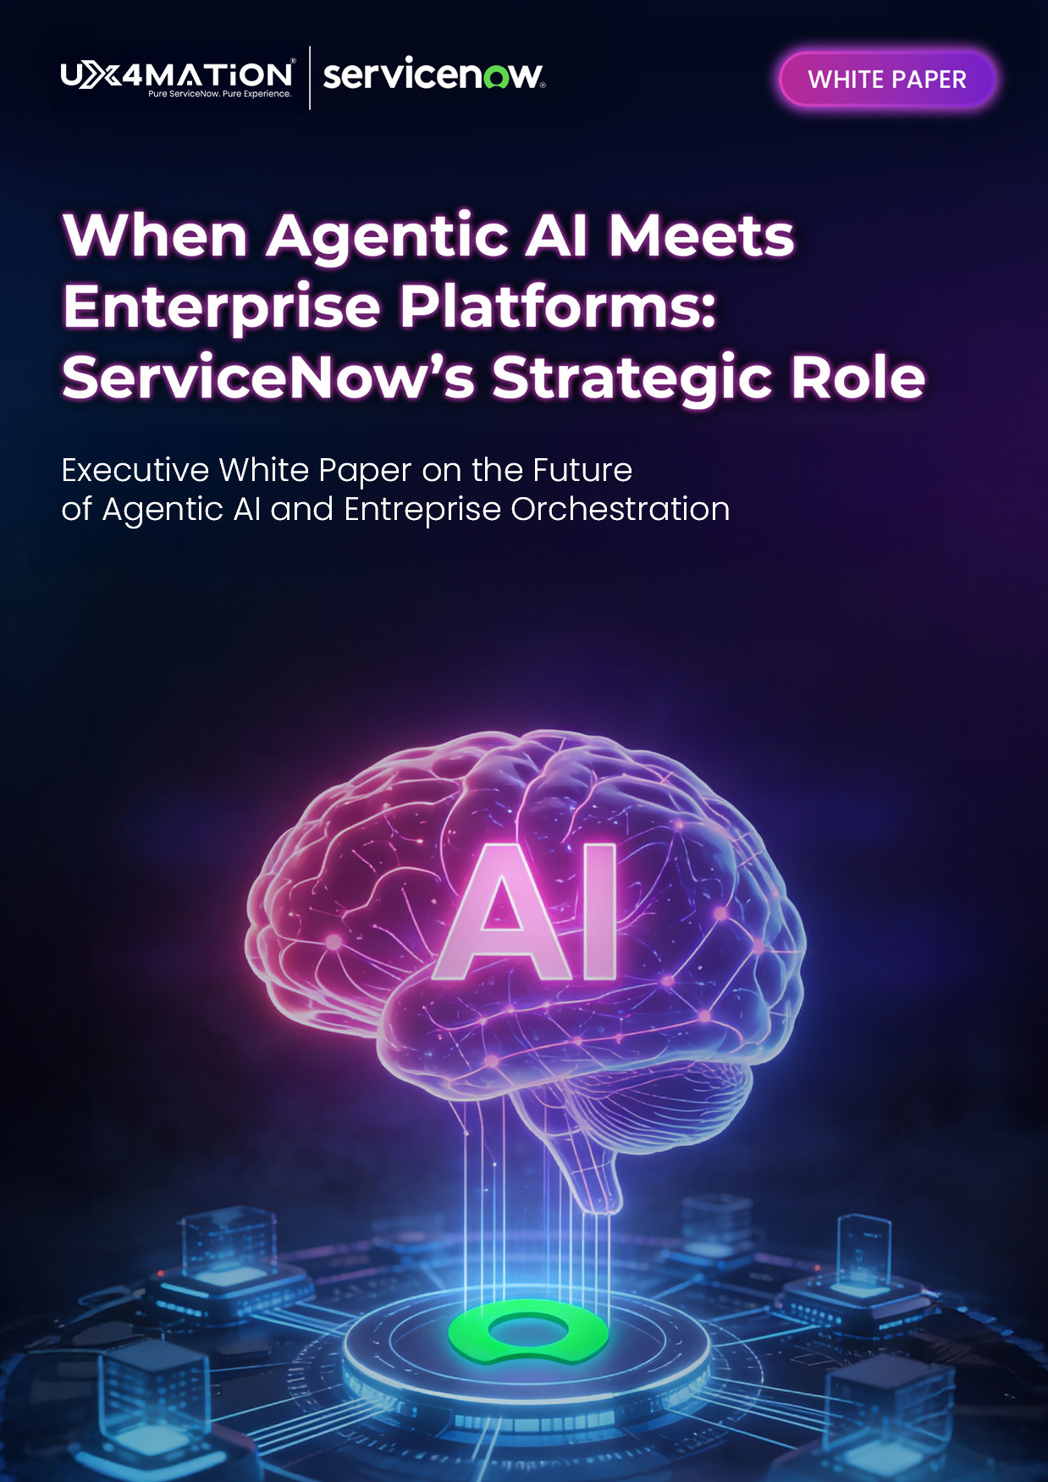
Executive White Paper on the Future
of Agentic AI and Entreprise OrchestrationExecutive White Paper on the Future
of Agentic AI and Entreprise Orchestration


Agenda

1. Executive Summary
1.1 The efficiency promise of enterprise AI
1.2 The counterweight: cost opacity, compliance, and trust
1.3 Why European leaders must move deliberately but now
2. The State of AI: Global Momentum vs. European Reality
2.1 Global Context
2.1.1 The acceleration toward Agentic AI and end-to-end automation
2.1.2 Competitive pressure from US and APAC markets
2.2 The European Lens
2.2.1 Regulatory environment: GDPR, EU AI Act, sector-specific rules
2.2.2 Data residency and sovereignty expectations
2.2.3 Cultural conservatism toward automation and risk
2.3 The Enterprise Platform Perspective (ServiceNow as Example)
2.3.1 How platforms are adapting for Europe
2.3.2 Local data centers and regional deployment models
2.3.3 EU-compliant AI capabilities vs. global-first offerings
3. The Economics of AI: ROI & Cost Modeling
3.1 The Cost of "Doing"
3.1.1 Understanding AI consumption models (e.g., Assist tokens)
3.1.2 Cost differentiation by workflow size (Small / Medium / Large)
3.1.3 Why transparency matters for CFOs and CIOs
3.2 The Value Equation
3.2.1 Moving beyond "time saved"
3.2.2 Measuring deflection, error reduction, and consistency

3.2.3 Linking AI outcomes to business KPIs


4. Navigating Risk: Compliance & Regulation
4.1 The EU AI Act

4.1.1 Risk-based classification and transparency obligations

4.1.2 What enterprise buyers must demand from vendors
4.2 Data Sovereignty
4.2.1 Keeping European data in Europe
4.2.2 Practical implications for architecture and vendor choice
5. Conclusion: A Pragmatic Path Forward
4.5.1 Balancing innovation with control
4.5.2 Building the foundation before scaling AI
4.5.3 Call to action for European enterprise leaders


1. Executive Summary
Enterprise AI is no longer about experimentation. Across IT, HR, Customer Service, and Operations, organizations are under pressure to deliver faster execution, higher quality, and lower operational cost without sacrificing stability, security, or compliance.
The efficiency promise of enterprise AI is real. Early adopters are already seeing tangible gains: reduced resolution times, improved agent productivity, and more consistent service delivery.
However, this promise comes with a counterweight:
- Cost opacity driven by consumption-based AI models
- Compliance and regulatory exposure in governed environments
- Loss of trust when AI operates outside transparent enterprise controls
For European enterprise leaders, the challenge is not whether to adopt AI, but how to do so responsibly.
The organizations that will succeed are those that embed AI inside enterprise platforms, where governance, workflows, and accountability already exist rather than deploying AI as an external layer.

2. The State of AI: Global Momentum vs. European Reality
2.1 Global Context
Globally, enterprises are accelerating toward Agentic AI and end-to-end automation.
In the US and APAC markets, organizations are already deploying AI to:
- Automate complex service workflows
- Reduce dependency on manual intervention
- Increase operational velocity and scalability

Speed of execution has become a competitive differentiator. AI is no longer just assisting humans. It is beginning to act, plan, and coordinate work autonomously.

2.2 The European Lens
In Europe, this momentum operates under significantly different constraints.
Enterprise AI adoption must contend with:
- GDPR and the EU AI Act
- Sector-specific regulatory obligations
- Strict data residency and sovereignty expectations
- Cultural conservatism toward uncontrolled automation
AI adoption in Europe cannot be reckless. It must be explainable, auditable, and controlled.
This regulatory and cultural environment slows adoption but also makes AI more strategic. European leaders must balance innovation with responsibility from day one.

2.3 ServiceNow’s Response: Centralized Control by Design
Enterprise platforms are evolving to respond to this European reality.
ServiceNow illustrates how platforms are adapting by providing:
- European data centers and regional deployment models
- EU-compliant AI capabilities
- Built-in governance, role-based access, and auditability

Rather than treating AI as an external add-on, ServiceNow embeds AI directly into enterprise workflows, where cost control, compliance, and trust are already enforced. 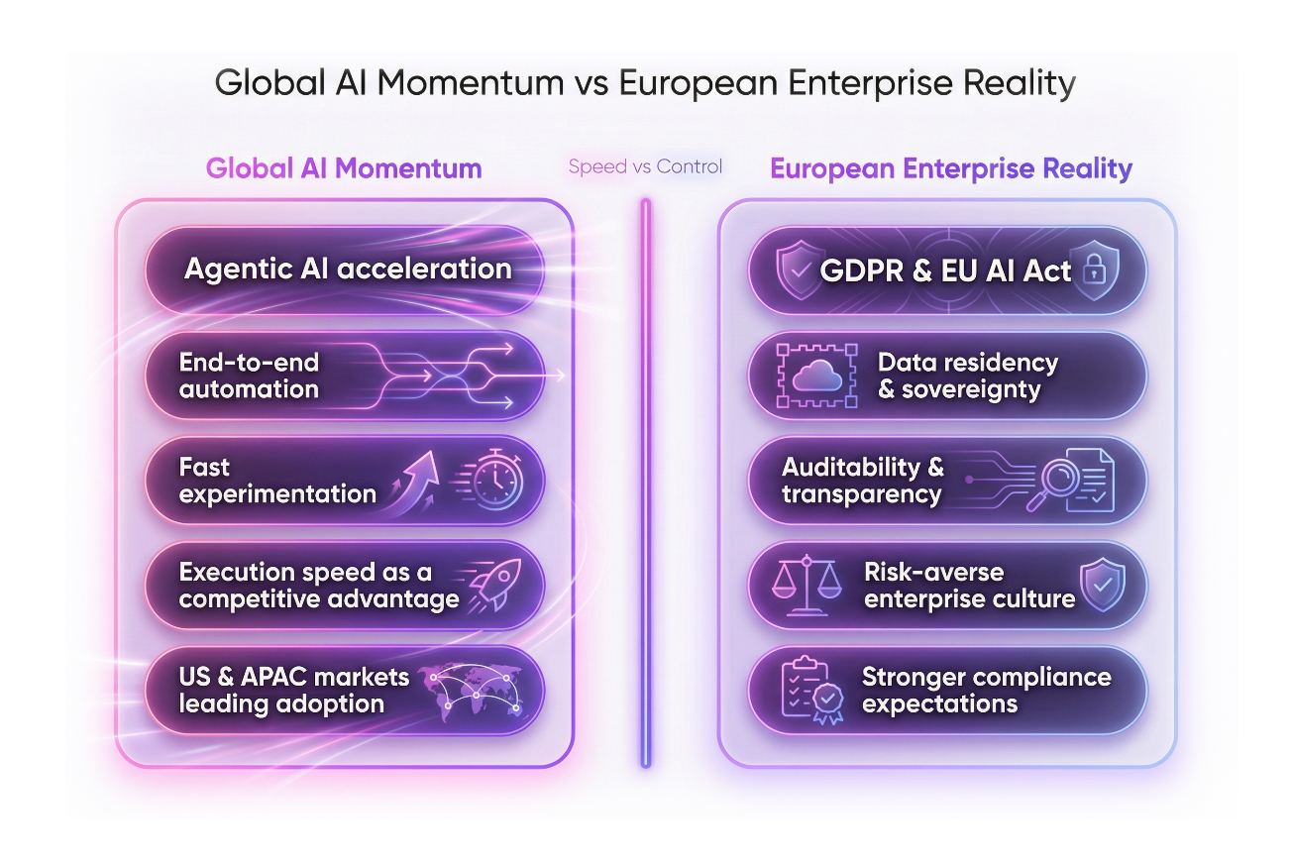
3. The Economics of AI: ROI & Cost Modeling
3.1 The Cost of "Doing": Understanding the Consumption Model (Assists)
To provide transparency and scalability, ServiceNow has moved away from traditional per-user pricing for AI features. Instead, the platform uses a consumption-based model centered on a unit called an "Assist."
- What is an "Assist"? Think of an "Assist" as a single unit of AI work. Every time Now Assist performs a cognitive task for a user—such as summarizing an incident, generating a knowledge article, or providing a "Genius Result" in a search—it consumes a specific number of assists from a global pool.
- A "Pool" for the Enterprise: Assists are typically pooled at the account level. This means your organization has a bucket of credits that can be used across different departments (IT, HR, Customer Service). You aren't restricted by who uses the AI, but rather by the total volume of work the AI performs.

- Predictability through the Admin Console: ServiceNow provides a Now Assist Overview dashboard. This allows business leaders to see exactly which skills (e.g., Incident Summarization vs. Code Generation) are consuming the most units. This transparency helps you align your AI spend directly with the departments and use cases that are providing the most value.
- Assist consumption: ServiceNow provides a detailed guidelines on the “cost” for AI usage, Generative AI (skills) consumes less assists compared to Agentic solutions, so this is the first filter to limit the usage of Agentic solution only for high valuable use cases.
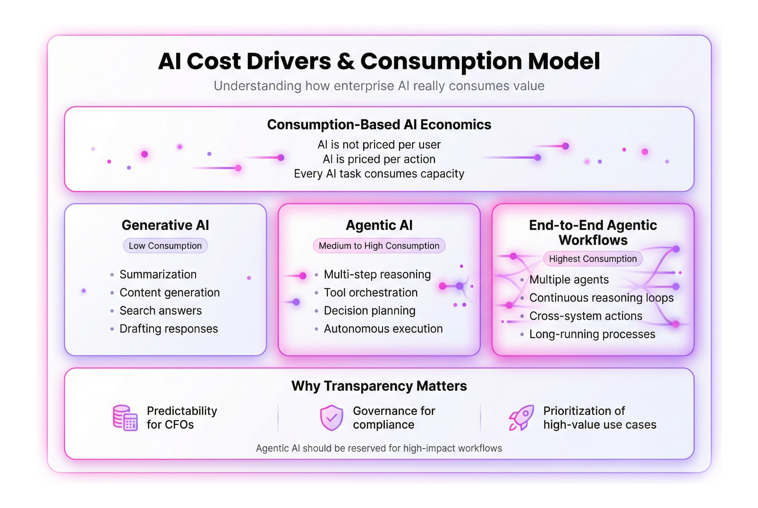
3.2 The Value Equation: Calculating ROI Beyond "Time Saved"
While "minutes saved" is the most immediate metric, the true ROI of Now Assist and Agentic AI is found in the quality and velocity of the service. A comprehensive ROI model looks at three distinct pillars:

- Direct Productivity (Time Saved): This is the "speed" metric. For example, if an agent saves 5 minutes per incident by using AI-generated summaries and resolution notes, those minutes aggregate into thousands of hours of reclaimed capacity across the global service desk.
- Deflection (Volume Reduction): The most significant cost saver is the work that never reaches a human. By using Now Assist in Virtual Agent, users can resolve complex issues through conversational self-service. Every successful deflection represents the total cost of a "Level 1" ticket saved.
- Error Reduction & Accuracy (Quality): Traditional manual documentation is prone to human error. AI ensures that resolution notes and knowledge articles are consistent, structured, and complete. This "Quality ROI" manifests in:
  - Reduced MTTR (Mean Time to Resolution): Better documentation means the next agent solves a similar problem faster.
  - Lower Re-open Rates: More accurate first-time fixes reduce the "ping-pong" effect of tickets bouncing between groups.


By combining these three pillars, IT leaders can move from a simple cost-savings conversation to a Value Realization strategy that proves how AI is transforming the operational efficiency of the business.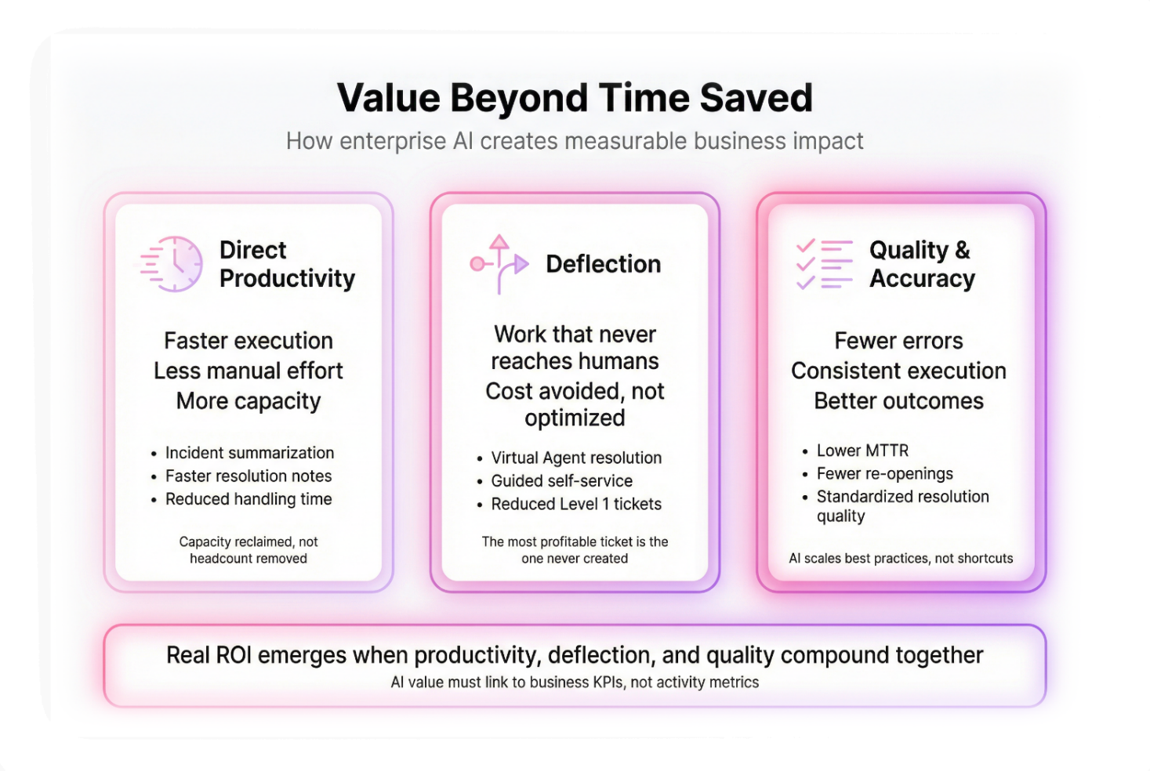

4. Navigating Risk: Compliance & Regulation
4.1 The EU AI Act
The EU AI Act introduces a risk-based framework for AI systems, with obligations around transparency, human oversight, and auditability.
Enterprise buyers must demand AI systems that can operate within these constraints.
Platforms, not standalone AI tools, are best positioned to meet these requirements.


4.2 Data Sovereignty
For European enterprises, data sovereignty is non-negotiable.
This means:
- Keeping European data in Europe
- Controlling where AI models execute
- Ensuring vendor architectures align with regulatory expectations
AI architecture choices directly impact compliance posture, vendor risk, and long-term scalability. 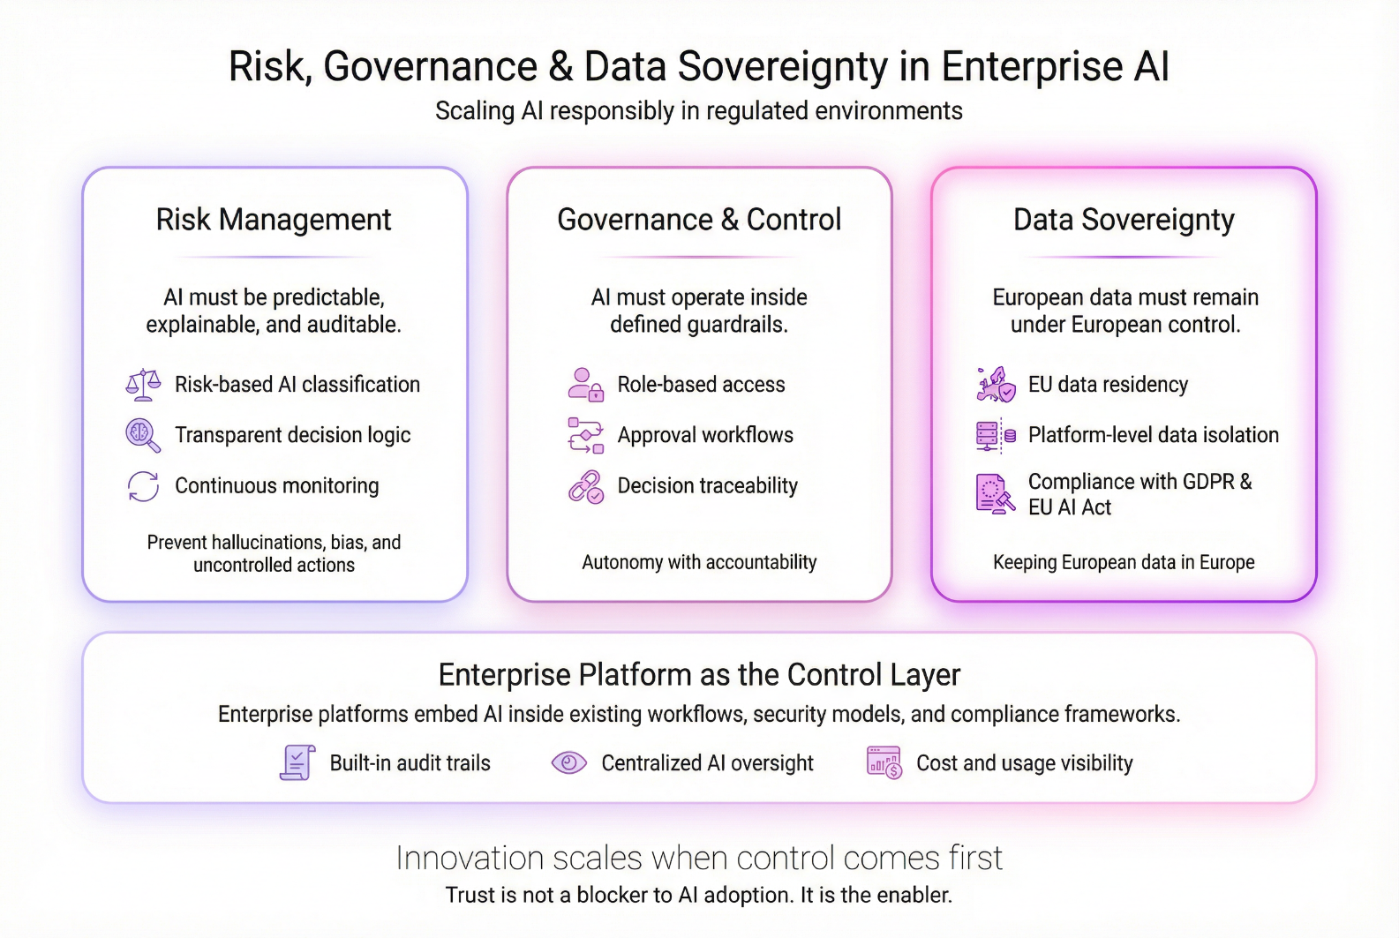


5. Conclusion: A Pragmatic Path Forward
Agentic AI is not a feature. It is a capability.
For European enterprises, success depends on:
- Embedding AI inside enterprise platforms
- Ensuring cost transparency
- Designing compliance by default
- Scaling autonomy progressively
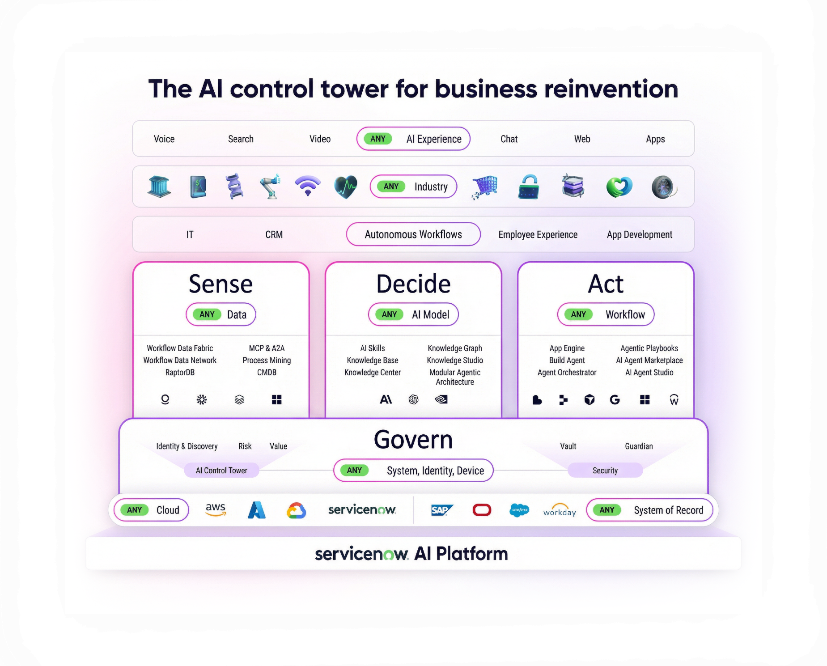ServiceNow’s AI Control Tower enables organizations to take control of any AI from a single, intelligent hub connecting AI strategy, governance, and execution across the enterprise.

Through its multi-model strategy, ServiceNow orchestrates best-in-class AI providers without locking customers into a single model. OpenAI powers high-engagement, multimodal interactions across Now Assist, while Anthropic’s Claude provides advanced reasoning for compliance-heavy and regulated workflows. Strategic acquisitions including Moveworks, Logik.ai, Armis, and Veza further strengthen workflow intelligence, security, and identity context.
By acting as the AI Control Tower for business reinvention, ServiceNow provides a proven template for moving from proof-of-concept AI to production-grade, governed agents turning autonomy into competitive advantage without sacrificing trust.

